*National University of Science and Technology*

**School of Mechanical and Manufacturing Engineering**

**Home Task #05**

**CS-114 Fundamentals of Programming**

**Course Instructor:** Khawaja Fahad Iqbal

**Lab Instructor:** Muhammad Affan

**Introduction:**

**Name:** Muhammad Furqan Ul Arsh

**CMS ID:** 476347

**Section:** ME-15B

**Date:** 01-11-2023

**Task 1:**

Write a program in C++ to find LCM of any two numbers using HCF.

**Solution:**

//Task 1 Program to find LCM Of two numbers using HCF

#include<iostream>

using namespace std;

int main(){

int num1,num2,hcf,lcm;

cout<<”Enter first number: “<<endl;

cin>>num1;

cout<<”Enter second number: “<<endl;

cin>>num2;

for(int i=1; i<=num1&&i<=num2;i++){

if(num1%i==0&&num2%i==0){

hcf=i;

}

}

lcm=(num1*num2)/hcf;

cout<<”LCM of numbers is: “<<lcm<<endl;

return 0;

}

**Result:**

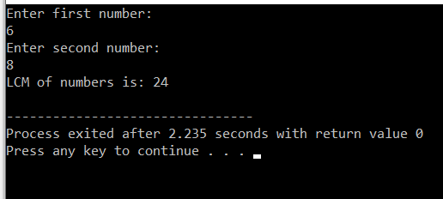

**Task 2:**

Write a program in C++ to find out the sum of an Arithmetic progression series.

**Solution:**

//Task 2 Program To find Sum of Arithmetic Progression

#include <iostream>

using namespace std;

int main(){

int a,n,d,sum,i;

cout<<"Enter First Term: ";

cin>>a;

cout<<"Enter The Number Of Terms: ";

cin>>n;

cout<<"Enter The Common Difference: ";

cin>>d;

for(i=0;i<n;i+=1){

sum+=a+i*d; //The Loop Will Sum The Values until it reaches total number of terms.

}

cout<<"The Sum Of Arithmetic Progression Series is "<<sum<<endl;

return 0;

}

**Result:**

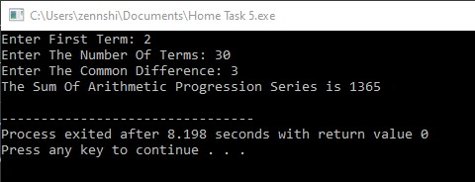

**Task 3:**

Write a program in C++ to create a diamond.

**Solution:**

//Task 3 Program to create a diamond

#include <iostream>

using namespace std;

int main() {

int n, space;

// Input the number of rows (should be an odd number for a perfect diamond)

cout<<"Enter the number of rows: "<<endl;

cin>>n;

if(n%2==0){

cout<<"Please enter an odd number for a perfect diamond."<<endl;

}

// Print the top half of the diamond

for(int i=1;i<=n;i+=2) {

// Print leading spaces

for (space=0;space<(n-i)/2;space+=1) {

cout<<" ";

}

// Print stars

for(int j=1;j<=i;j+=1){

cout<<"*";

}

cout<<endl;

}

// Print the bottom half of the diamond

for(int i=n-2;i>=1;i-=2){

// Print leading spaces

for(space=0;space<(n-i)/2;space++){

cout<<" ";

}

// Print stars

for (int j = 1; j <= i; j++) {

cout<< "*";

}

cout<< endl;

}

return 0;

}

**Result:**

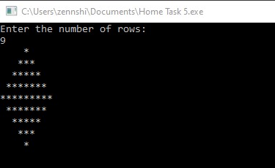

**Task 4:**

Write a program in C++ to convert a decimal number to binary number.

**Solution:**

//Task 4 Program to convert decimal to binary number

#include <iostream>

using namespace std;

int main(){

int dnum,bnum,remainder,base=1;

cout<<”Enter a Decimal Number: “;

cin>>dnum;

while(dnum>0){ //While loop calculates the binary number by evaluating the remainder of decimal number

remainder=dnum%2;

bnum=bnum+remainder*base;

dnum/=2;

base*=10;

}

cout<<”The Binary Number Equivalent Of Given Decimal Number is: “<<bnum<<endl;

return 0;}

**Result:**

